# Creating Roles in SQL

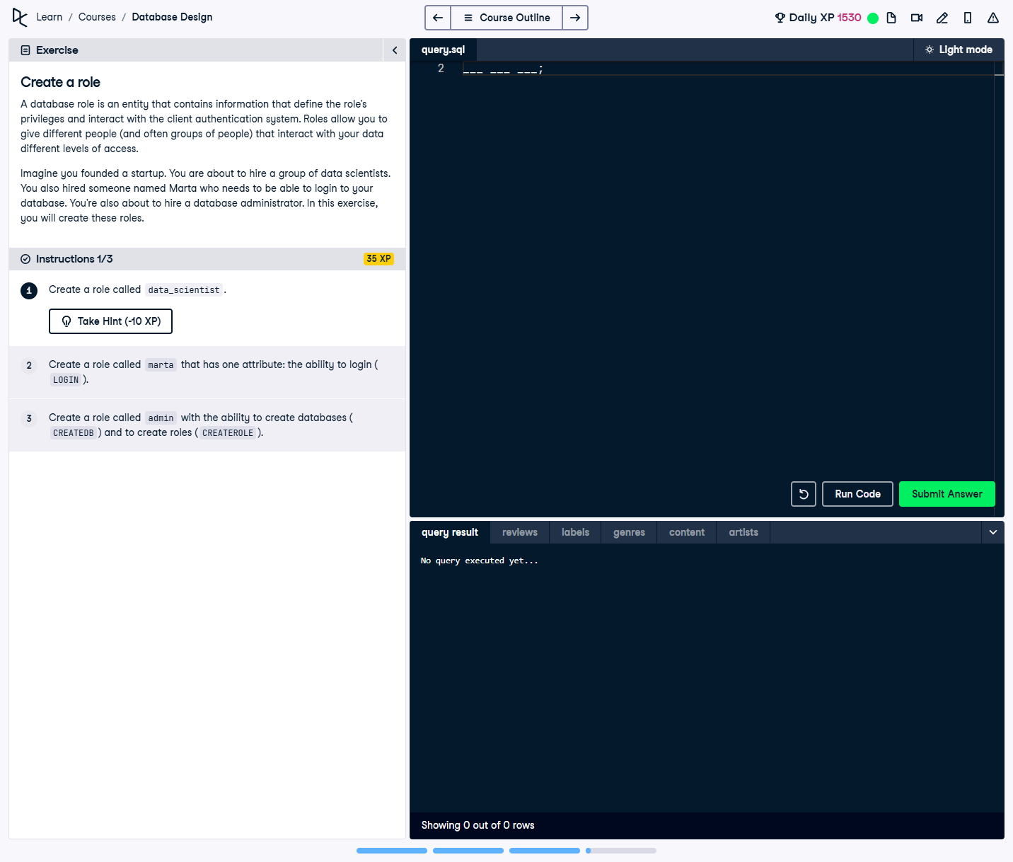

## Question:

A database role is an entity that defines privileges and authentication settings for database users. The task requires creating three roles:  
1. A `data_scientist` role.  
2. A `marta` role with login ability.  
3. An `admin` role with database creation (`CREATEDB`) and role creation (`CREATEROLE`) permissions.

## Full Answer (SQL Code):

-- Create a role called data_scientist  
CREATE ROLE data_scientist;  
  
-- Create a role called marta with the ability to login  
CREATE ROLE marta LOGIN;  
  
-- Create a role called admin with the ability to create databases and roles  
CREATE ROLE admin CREATEDB CREATEROLE;

## Explanation of the Answer:

The `CREATE ROLE` command is used to define new database roles. The `data_scientist` role is created without additional privileges. The `marta` role includes `LOGIN`, allowing direct authentication. The `admin` role is given the `CREATEDB` privilege to create databases and `CREATEROLE` to create new roles.